
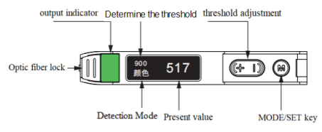
Color Amplifer Sensor BS-502 series
User Manual
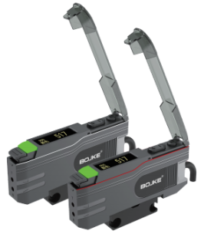
Warning
This product does not have explosion-proof structure.Prohibit use inflammable,explosive gas or explosive liquid environments.
Do not disassemble or modify this product as it is not designed to automatically turn off laser emission when the product is opened.If the client disassembles or changes this product without permission, it may cause personal injury,fire or electric shock danger.
If do not according the manual to control,adjust or operate may cause dangerous radiation leaks.
Notes
Wiring,connecting/disconnecting interfaces,and other operations when power is turned on are very dangerous.Please be sure to turn off the power before operation.
Installation in the following places may cause malfunctions:
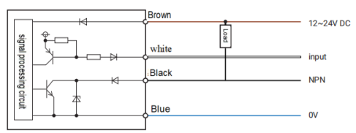
1、A place full of dust or steam
2、A place where have corrosive gases
3、A place where water or oil can directly spill
4、A place with serious vibration or impact
This product is not suitable for outdoor use
Do not use this sensor in an unstable state(e.g:short time after power turn on),need about 15 minutes warm up time.
If it is necessary to use a switching power regulator,please ground the grounding terminal. Don’t connect to high-voltage cables or power lines.Failure to operate will cause sensor damage or malfunction, each product in differences,Therefore, there may be slight differences in detection characteristics of the product.
Do not use this product in water
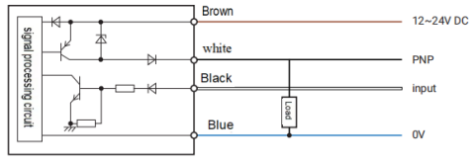
Please do not disassemble, repair, or modify this product without authorization, as this may result in electric shock, fire,or injury to human body.
Clean the dust on the transmitting or receiving components to maintain correct detection.Avoid direct impact of objects on this product
Operate within the rated range.

This product can not be used as a safety device to protect the human body

Calibration Teach
panel Description
two point teaching

Short press SET to “calibrate the measured object”when aligning themeasured object, and short press SET to “complete two-point calibration” when aiming at the background.

【The color of the test is set to 999, and the judgment threshold is set to the median value of the similarity between the test object and the background (30 seconds without operation to exit the calibration)】
calibration failed

when the calibrated DUT is too similar to the background, it will display”calibration failure”because it cannot effectively distinguish the colors, and the calibration will be invalid and recalibration will be required

【If the calibration fails,the color parameters stored when the previous calibration was successful will also be overwritten】
【 If the calibration fails, the threshold is automatically changed to 999】
Specifications
Dimensional Drawing
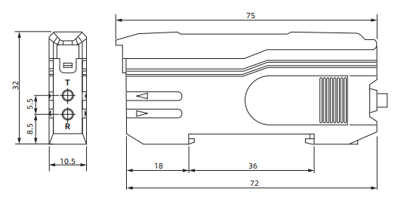极性反接保护/浪涌保护/短路保护

Circuit Diagram
NPN

PNP
1 2 3

Model | NPN | BS-502LG | BS-502
Model | PNP | BS-502LGP | BS-502P
Power Supply |  | DC12~24V±10%
Consumer Current |  | ＜25mA
Sensing Range |  | According the optical fiber
Light Source |  | RGB LED | White LED
Detection Mode |  | Color Mode and Mark Mode
Response Time |  | ＜1ms
Response Frequency |  | >1000Hz
Max Current |  | 100mA
Residue Voltage |  | ＜1.5V
Switching Mode |  | N.O / N.C
Ambient Illuminance |  | Incandescent lamp≤3000Lux；Sunlight≤10000Lux
Ambient Temperature |  | working：-10℃~55℃; storage： -25℃~70℃,no freezing
Ambient Humidity |  | Working: 35%~85%RH; storage: 35%~95%RH, No condensation
Protection Circuit |  | polarity reversal protection/surge protection/short circuit protection
Protection Degree |  | IP64
Connection Type |  | Cable type（4-core，2meter）
Housing Material |  | ABS
Vibration Resistant |  | 10~55Hz, dual amplitude 1.0mm, X/Y/Z each directions 30min
Impact Resistant |  | 300m/S²,X/Y/Z each direction 3 times

Interaction and Menu
Threshold adjustment
Adjust in range of 0~999 with +/- key
External input
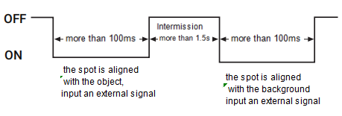
Key Locking
”Press and hold the “M”/”-” 3 seconds at same time,
And the screen will show “Locked”/”Unlocked”
Menu Setting
① Press and hold MODE for 3 seconds to enter the Level 1 menu; Short press MODE to switch to the level 1 menu
② +/- switch to level 2 menu
③ After 30 seconds of no operation, it will automatically exit the menu and return to detection mode(the modifying will not be saved)
④ After modifying the settings, short press MODE several times to the exit menu to save the setting changes

Level 1 menu | Level 2 menu
1.Detection mode | Mark mode |  | Color mode
2.NO/NC | N.O |  | N.C
3.Fiber brightness | Mid |  | Max
4.External input | input is invalid |  | Calibrate the color
5.Output setting | Off | On-delay | Off-delay |  | One-time shot
6.Timer | 0ms~999ms
7.Prevent interference | Channel A |  |  | Channel B
8.Display | Forward |  |  | Backward
9.Initialize | Cancel reset |  |  | Factory reset
10.Exit menu | Save setting
After factory reset:Color Mode, Normally On, Medium, Invalid Input, Off,0ms, Channel A, Forward display

Product Warranty
When ordering our products only reference sample,the following guarantees, disclaimers, conditions of fitness etc should apply when no special instructions are mentioned in the quotation sheet,contract, specification,etc.
Before order please ensure you read and confirming following.
1、Quality Guarantee Period
Quality guarantee period is one year,calculated from the date when product delivered
to buyer’s destination.
2、Range of guarantee
We will repair the commodity free if the damage caused by our company.
It’s will not belong to the range of guarantee if caused by following reason:
- Damage caused by use outside of the conditions,environment and use method
described in the product manual of the company.
- Faults not caused by our company
- Product damage caused by the personal modification and repair except the manufacturer.
- Didn’t according to usage method of our company description.
- After the goods are delivered, the problem caused by unpredictable scientific level.
- Other failures caused by natural disasters and other factors.

At the same time, the above guarantee only refers to the company’s products, and the other damage caused by the company’s product failure is excluded from the guarantee range.

3、Limits of liability
1) The Company should not be liable for any special loss, indirect loss, and other related losses (eg:equipment damage, loss of opportunity, loss of profit) caused by incorrect use of company’s products.
2)When using programmable equipment,our company will not assume any responsibility for the programming carried out by non-company personnel and the consequences arising therefrom.

4、Suitable for use and conditions
1)The products of our company are designed and manufactured for general products of general industry. So,the products of our company should not be used for the following applications and not suitable for their use.If it is necessary to be used in the following occasions,please discuss with the sales of our company to confirm the product specification, and select the product which suitable.At the same time, we should consider various safety countermeasures, such as the safety circuit that can minimize the danger even if there is a failure.
A.Facilities that have a serious impact on life and property, such as atomic energy control equipment,incineration equipment, entertainment equipment,safety devices and equipment, entertainment equipment,safety devices and equipment that must comply with the special provisions of administrative agencies and individual industries.
B.Public utilities such as gas,water,power supply systems, 24-hour continuous operation systems and other equipment requiring high reliability.
C.Systems,equipment and devices that may endanger personal and property.
D.Outdoor use under similar or similar conditions.

2)When the user uses the company’s products in occasions closely related to personal and property safety,the overall risk of the system,supporting power distribution and settings should be supply.

3)Please be sure to follow the precautions and prohibitions to avoid incorrect use and damage caused by a third party.
5、Range of Services
The product price does not include the dispatch fee of technicians and other service fees.If you have any demand in this, you can contact us to negotiate.

4 5

